**Chatter** for messages, notes, and followers

**tracking** for logging field changes

**Step 1: Update __manifest__.py file**

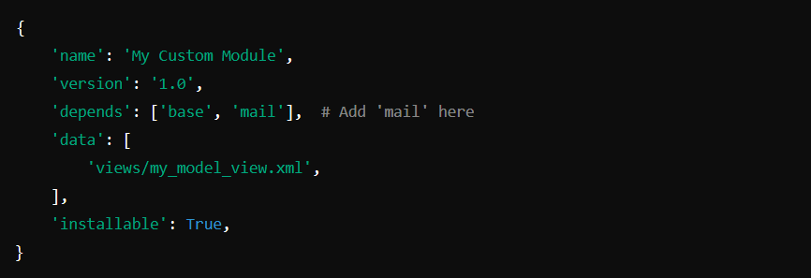

**Step 2: Inherit mail.thread and mail.activity.mixin**

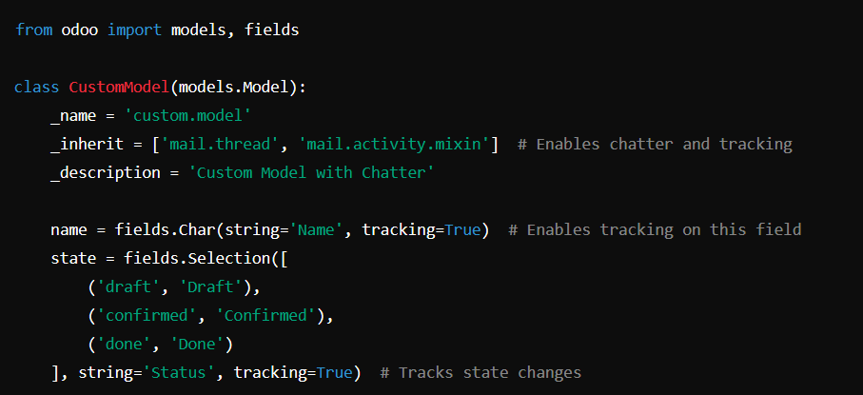

**Step 3: Add Chatter in Form View**

In your XML view file (custom_model_views.xml), add a chatter widget inside the form view.

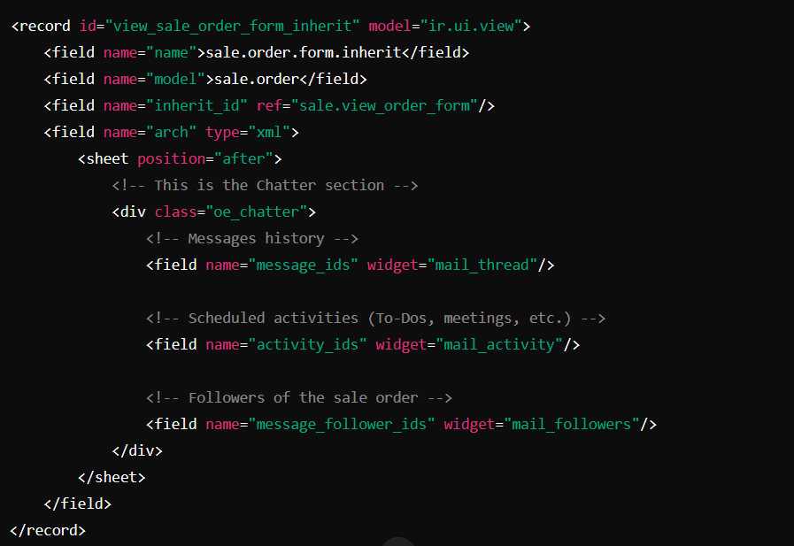

<field name="message_follower_ids" widget="many2many_tags" readonly="1"/>

**Key Differences**

| **Feature** | **tracking=True (Odoo 14+)** | **track_visibility='onchange' (Odoo 13 and earlier)** |
| --- | --- | --- |
| **Odoo Version** | Odoo 14+ | Odoo 13 and earlier |
| **Tracking Mechanism** | Uses new mail tracking | Older method |
| **Recommended?** | ✅ Yes | ❌ No (Deprecated) |
| **Performance** | ✅ Better, optimized | 🔴 Less efficient |
| **Where to use?** | _inherit = ['mail.thread'] models | Older models only |